**Magnetic Field of a Current Carrying Wire**

[Modified from PASCO lab manual #87]

**Pre-lab questions:**

1. What is the goal of this experiment? What physics and general science concepts does this activity demonstrate?
2. What is the expected axial magnetic field strength at the center of a current carrying coil of wire? How is this different from the expected strength inside a long solenoid?
3. Why can’t we presume that the equation for a long solenoid will describe our experimental coil?
4. What effect should reversing the direction of the current have on the magnetic field created by the current carrying coil?

**Equipment:**

* AC/DC electronics laboratory
* Rotary motion sensor
* 3-axis magnetic field sensor
* Short patch cords (set of 8)
* Large rod base & 90-cm rod (stainless steel)
* Thread
* Mass and hanger set

The goal of the experiment is to examine the radial and axial magnetic fields of a current carrying coil. The fields are plotted versus position as the magnetic field sensor is passed through the coil. Position is recorded by a string attached to the magnetic field sensor that passes over the rotary motion sensor pulley to a hanging mass.

**Introduction:**

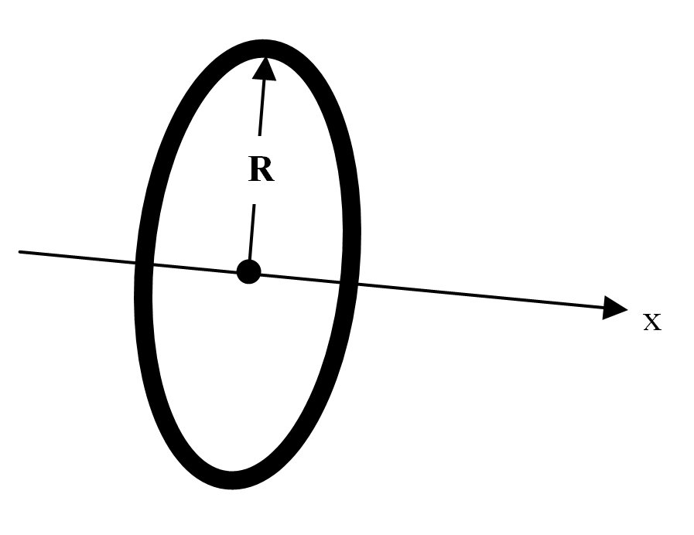

Magnetic field of a single coil

For a coil of wire (of negligible length) with radius *R* and *N* turns of wire, carry a current *I*, the magnetic field along the perpendicular axis through the center of the coil is given by equation 1. The point at the center of the coil is $x=0$ in this equation, as shown in figure 1.

Figure 1: Single coil of radius R and negligible length.

$$\begin{aligned}B_{axial}=\frac{μ_{0}NIR^{2}}{2{\left(x^{2}+R^{2}\right)}^{3/2}}\#\left(1\right)\end{aligned}$$

Magnetic field of a long solenoid

A solenoid is a coil of wire of non-negligible length *L* with *n* turns of wire per unit length ($n=\frac{N}{L}$). The magnetic field inside a long solenoid is given by:

$$\begin{aligned}B_{axial}=μ_{0}nI\#\left(2\right)\end{aligned}$$

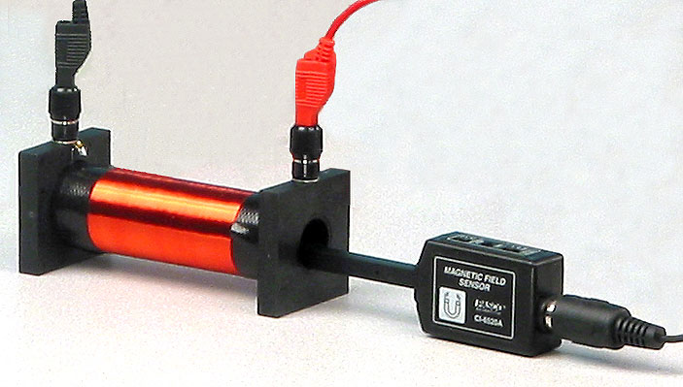This field is axial – the direction of the field is straight down the axis of the solenoid. For a solenoid to be considered long, the length of coil must be much longer than the diameter of the coil ($L≫D$). An example of a solenoid is shown in figure 2. It is worth noting that equation 2 will begin to fail to describe the magnetic field of the solenoid as the ends are approached. At this point, the magnetic field will begin to decrease as you exit the solenoid.

Figure 2: Image of a long solenoid with magnetic field sensor inserted.

Magnetic field of a short solenoid

The solenoid included on the AC/DC electronics laboratory kit is not considered a “long” solenoid. The coil has about $N=600 \text{turns}$, an average radius of about $R=1.5 \text{cm}$, and a length of $L=2.5 \text{cm}$. Neither equation 1 nor equation 2 is a correct approximation of the magnetic field created by this coil. However, both equations should give upper bound values for the magnetic field at the exact center of the coil. You will calculate this theoretical magnetic field strength $B_{theory}$ and compare it to your experimental results.

## Experiment:

***Set up:***

1. 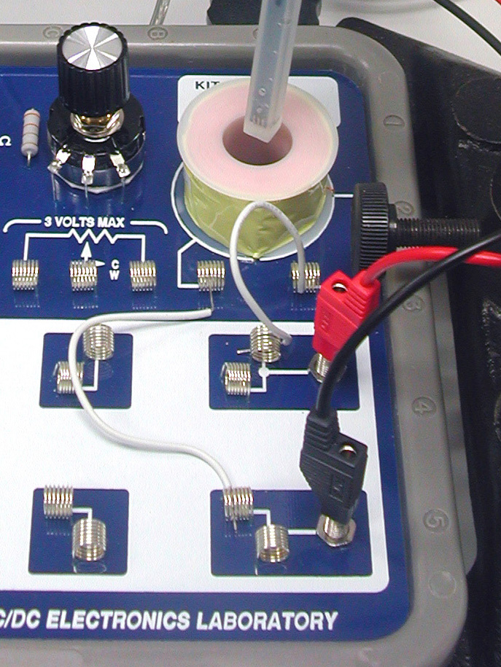Remove the large plastic bolt from the center of the coil. Note: replace the bolt at the end of the experiment. Otherwise the coil tends to be pulled loose from the circuit board.

Figure 3: Circuit board connections

1. Connect white wire jumpers from the coil connector springs to the banana inputs for the Electronics Laboratory as shown in Figure 3.
2. Connect red and black patch cords from the Electronics Laboratory inputs to red and black jacks for Output 1 on the 850 Universal Interface.
3. 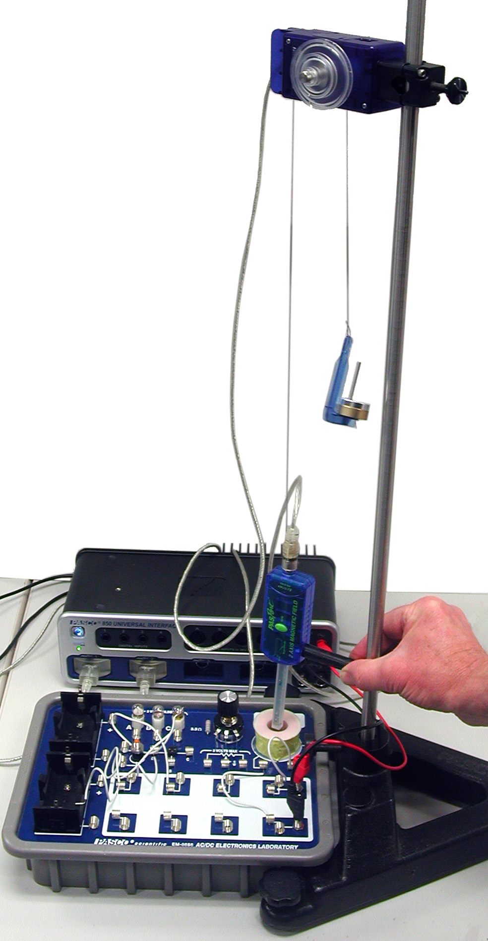Attach the 90 cm rod to the base and position the base by the Electronics Laboratory as shown in Figure 4.

Figure 4: Equipment set up

1. Attach the Rotary Motion Sensor (RMS) to the rod as in Figure 4.
2. Cut a piece of thread about 1 m long.
   1. Tie one end of the thread around the strain relief in the cable attached to the Magnetic Field Sensor so it catches in one of the grooves as shown in Figure 4.
   2. Pass the other end of the thread over the large step of the RMS pulley and attach a mass holder carrying an additional 60 g of mass.
3. Adjust the positions so the thread between the RMS and the Magnetic Field Sensor is vertical when the sensor is centered on the coil.
   1. Attach the sensor handle to the Magnetic Field sensor.
   2. Adjust the positions so that while holding the end of the sensor handle against the 90 cm rod, you can move the sensor up and down along the magnetic field axis.
4. Plug the Magnetic Field Sensor and the Rotary Motion Sensor into any two of the PASPORT inputs on the 850 Universal Interface.
5. In PASCO Capstone, open the Hardware Setup and click on the Signal Generator #1 and select the Output Voltage Current sensor.
6. Set the Common Sample Rate to 20 Hz.

***Solenoid Procedure:***

1. In PASCO Capstone, create a graph of Magnetic Field Strength (Axial) vs. Position.
2. With the DC power off, put the Magnetic Field Sensor probe into the coil so the sensor is at the center of the coil. Note that the actual vertical position of the sensor is indicated by the white dot on the side of the probe away from the labels on the sensor body.
3. Press the Tare button to zero the sensor.
4. On the Experiment Control Bar, select the Rotary Motion Sensor and click on the Zero Now button.
5. Click open Signal Generator. Set Output 1 for a DC Voltage of 5 V. Click Auto. Click the Signal Generator closed.
6. Insert the magnetic sensor probe through the solenoid as far as possible keeping the sensor handle against the steel rod.
7. Start recording.
   1. Move the probe slowly out of the solenoid and about 10 cm beyond, holding the sensor handle against the steel rod. Try to keep the sensor probe centered on the coil.
   2. Click STOP.
8. Examine the curve. If it is not symmetric about Position = 0, repeat the "Zero Sensor Now" adjust from step 1 above. It does not have to be perfect.
9. Click open Data Summary and re-label this run as "Center".
10. Repeat step 4 except this time rotate the Magnetic Field Sensor (keeping the sensor handle against the steel rod) so the probe is against the left edge of the coil. Label this run as "Left".
11. Repeat with the probe against the right edge of the coil. Label as "Right".
12. Reverse the red and black patch cords so current flow through the coil in the opposite direction. Repeat step 8 and label it "Right Reversed".
13. Replace the plastic bolt holding the coil to the circuit board.

***Radial Field Procedure:***

1. In PASCO Capstone, create a graph of the Magnetic Field Strength (Perpendicular) vs. Position. Select the Right, Left, and Center runs on the graph.
2. On the axis, there should be no perpendicular field due to the symmetry of the system. There is probably a small radial field due to failure to get the sensor right on the axis.
   1. *Analysis:* Does the field appear small for the "Center" run?
   2. Click the black triangle by the Run Select icon on the graph toolbar. Click "Center" to de-select it. The "Left" and "Right" runs should still show.
3. Note that the positive direction for the radial field is coming out of the side of the sensor with the labels on it. *Analysis:* Explain why the "Left" radial field looks the way it does.
4. *Analysis:* Explain why the "Right" radial field looks the way it does.
5. Click on the black triangle by the Run Select icon and select "Right Reversed" and click on "left" to de-select it. *Analysis:* Explain why they are different.

**Data:**

Include all PASCO generated plots. Be sure that each plot has a meaningful title, and that all axes are labelled including units of measurement.

**Computations, and Analysis:**

***Axial Field***

1. Use Equations 1 and 2 to calculate the upper and lower bound values for the axial magnetic field.
2. How do the first three runs compare with each other? What does this show about how uniform the magnetic field is across the coil (moving perpendicular to the axis of the coil)?
3. Note that the arrows on the Magnetic Field Sensor indicate the positive direction, so a positive field means that the field direction points upward. Does your data indicate that the field is upward or downward? Is the current in the coil clockwise or counterclockwise viewed from above?
4. Why is the "Right Reversed" run different from the other three?
5. How well did the estimates (since the values we used were only approximate) calculated using Equations 1 & 2 work out?

***Radial Field***

1. Does the field appear small for the “Center” run?
2. Explain why the “Left” radial field looks the way it does.
3. Explain why the “Right” radial field looks the way it does.
4. Explain why the “Right Reversed” field is different.

***Magnetic Field Model***

1. Open the Capstone calculator and make the following calculation:

‎

Btheory‎=0.5*μ₀*N*[Output Current‎]*R²*(([Position‎]-[d])^2+R²)^-1.5

with units of T

‎μ₀‎=[Permeability constant (H/m)‎]

‎N‎=600 unitless

‎I‎=0.8 with units of A

‎R‎=0.015 with units of m

‎d‎=0.0018 with units of m

1. On the graph of Magnetic Field Strength (Axial) vs. Position, use Add Similar Measurement on the vertical axis to add Btheory.
2. Recall from the theory that the Btheory model is based on Equation 1, which treats the coil as if it had zero length. *Analysis:* Why is the Btheory curve narrower than the experimental curve?
3. For positions outside the coil (-1.2 cm < position < +1.2 cm), the theory curve looks very similar to the experimental data. To see this, click open the Calculator and adjust the "d" value to shift the theory curve. Try to make Btheory match the data for positions > 1 cm. The best "d" value is probably around 0.0025 m, but the exact value depends on how well you set the zero and centered the curve on zero position. Can you make the model match the data for positions < -1 cm? *Analysis:* What does this tell us?

**Conclusions:**

How well did the estimates (since the values we used were only approximate) calculated using Equations 1 & 2 work out?

Did you successfully demonstrate the theory presented in the introduction?

**Sources of errors:**

What assumptions were made that caused error? What is the uncertainty in your final calculation due to measurement limitations?